**Test Case 4**

**System:** Bench

**Description:** Test that the user is able to accept an incoming chat request.

**Severity:** 4

**Instructions**

**Test 1**

1. Start the Bench application.
2. Click the button “Login” on the navigation bar.
3. Enter the email “rachel.la2310@gmail.com” into the text field labeled “Email address”.
4. Enter the password “12345678” into the field labeled “Password”.
5. Click the button “Login” below the field.
6. After the screen has loaded, click on the button “Chat” on the navigation bar.

**Expected Result:** If there exists one or more incoming chat requests, there should be one or a list of panels for each incoming chat request labeled with the request-sender’s username, a button for accepting it, and a button for declining it on the left side of the Chat page.

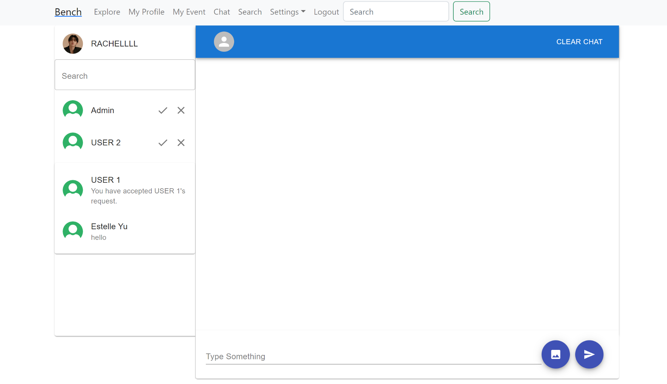

**Test 2**

1. Start the Bench application.
2. Click the button “Login” on the navigation bar.
3. Enter the email “rachel.la2310@gmail.com” into the text field labeled “Email address”.
4. Enter the password “12345678” into the field labeled “Password”.
5. Click the button “Login” below the field.
6. After the screen has loaded, click on the button “Chat” on the navigation bar.
7. If there exists one or more incoming chat requests, there should be one or a list of panels for each incoming chat request labeled with the request-sender’s username, a button for accepting it, and a button for declining it on the left side of the Chat page.
8. Select a chat request that you want to decline, and click on the button for declining on this chat request panel.

**Expected Result:** This selected chat request panel should disappear, and no chat room between the declined request sender and the current user should be created.

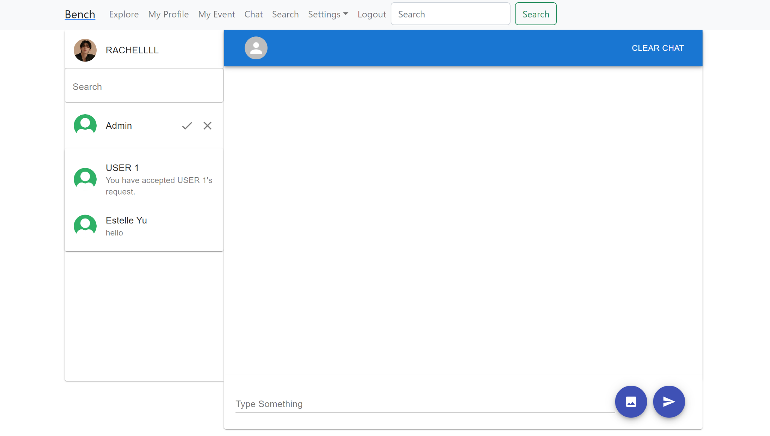

**Test 3**

1. Start the Bench application.
2. Click the button “Login” on the navigation bar.
3. Enter the email “rachel.la2310@gmail.com” into the text field labeled “Email address”.
4. Enter the password “12345678” into the field labeled “Password”.
5. Click the button “Login” below the field.
6. After the screen has loaded, After the screen has loaded, click on the button “Chat” on the navigation bar.
7. If there exists one or more incoming chat requests, there should be one or a list of panels for each incoming chat request labeled with the request-sender’s username, a button for accepting it, and a button for declining it on the left side of the Chat page.
8. Select a chat request that you want to accept, and click on the button for accepting on this chat request panel.

**Expected Result:** This selected chat request panel should disappear, and a new chat panel between the accepted request sender and the current user should be created.

